Chapter 7 revision Electrochemistry name: class:

1.掌握判断物质是否导电(从其状态与物质种类)
1. The diagram shows an incomplete circuit.
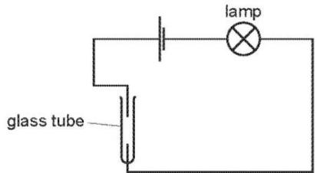
Which substance causes the lamp to light when added to the glass tube? （ ）
A aqueous sodium chloride
B aqueous sugar
C solid sodium chloride
D solid sugar

2.The diagram shows the circuit for electrolysing lead(II) bromide and sodium chloride to liberate the metal.
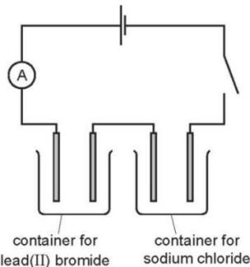
In what form are these salts electrolysed for liberating the metal? （ ）
 | lead(II) bromide | sodium chloride
A | concentrated solution | concentrated solution
B | concentrated solution | molten
C | molten | concentrated solution
D | molten | molten

3. - (0620- S 2014- Paper 1 (Core)/1- Q11) - ELECTRICITY AND CHEMICAL CHANGES
Which substance will not conduct electricity? （ ）
A aluminium B copper C plastic D steel

2.了解电解的原理
1.Which statement about electrolysis is correct? （ ）
A Electrons move through the electrolyte from the cathode to the anode.
B Electrons move towards the cathode in the external circuit.
C Negative ions move towards the anode in the external circuit.
D Positive ions move through the electrolyte towards the anode during electrolysis.
2. Which statements about the electrolysis of concentrated copper(II) chloride are correct? （ ）
1 Electrons are transferred from the cathode to the copper(II) ions.
2 Electrons move round the external circuit from the cathode to the anode.
3 Chloride ions are attracted to the anode.
4 Hydroxide ions transfer electrons to the cathode.
A 1 and 3 B 1 and 4 C 2 and 3 D 2 and 4

3. Aluminium is extracted by the electrolysis of aluminium oxide.
Which statement is not correct? （ ）
A Aluminium ions are oxidised at the cathode.
B Carbon dioxide is made at the anode.
C Cryolite is added to lower the melting point of the aluminium oxide.
D The electrodes are made from graphite.

4. The diagram shows a circuit used to electrolyse aqueous copper(II) sulfate.
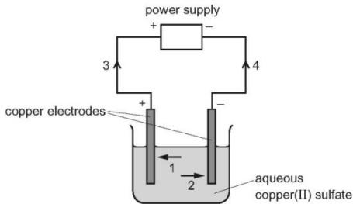
Which arrows indicate the movement of the copper ions in the electrolyte and of the electrons in the external circuit? （ ）
 | copper ions | electrons
A | 1 | 3
B | 1 | 4
C | 2 | 3
D | 2 | 4

5. The electrolysis of aqueous copper(II) sulfate, using inert electrodes, is shown.
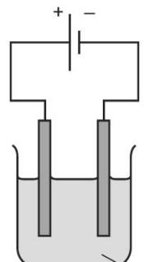
aqueous copper(II) sulfate
Which statement about a reaction at an electrode is correct? （ ）
A Copper ions gain electrons at the negative electrode.
B Copper ions gain electrons at the positive electrode.
C Hydrogen ions gain electrons at the negative electrode.
D Hydrogen ions gain electrons at the positive electrode.
6. During electrolysis, ions move in the electrolyte and electrons move in the external circuit. Reactions occur at the electrodes.
a.The diagram shows the electrolysis of molten lithium iodide.
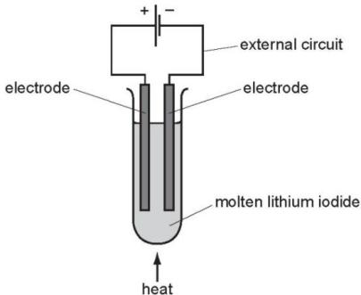
i.Draw an arrow on the diagram to show the direction of the electron flow in the external circuit. [1]
ii.Electrons are supplied to the external circuit. How and where is this done?

iii.Explain why solid lithium iodide does not conduct electricity but when molten it is a good conductor.
b.The results of experiments on electrolysis are shown in the following table. Complete the table. The first line has been done as an example.
electrolyte | electrodes | product at cathode | product at anode | change to electrolyte
molten lithium iodide | carbon | lithium | iodine | used up
aqueous copper(II) sulfate | platinum |  | oxygen
concentrated aqueous potassium chloride | carbon |  | chlorine
c.The diagram below shows the electrolysis of dilute sulfuric acid.
Hydrogen is formed at the negative electrode (cathode) and oxygen at the positive electrode (anode) and the concentration of sulfuric acid increases.
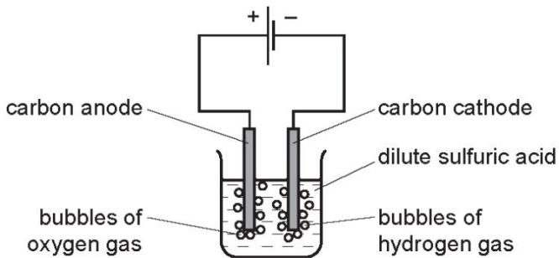
The ions present in the dilute acid are $H^{+}(aq)$ , ${OH}^{−}(aq)$ and ${SO}_{4}^{2−}(aq)$ .
i.Write an equation for the reaction at the negative electrode (cathode).
ii.Complete the equation for the reaction at the positive electrode (anode).
$$4{OH}^{−}(aq)→O_{2}(g)+……H_{2}O(l)+……$$
iii.Suggest an explanation of why the concentration of the sulfuric acid increases.
.......................................................................................................................................................................................................................................................................... [1]
d.In the apparatus used in (c), the power supply is removed and immediately replaced by a voltmeter.
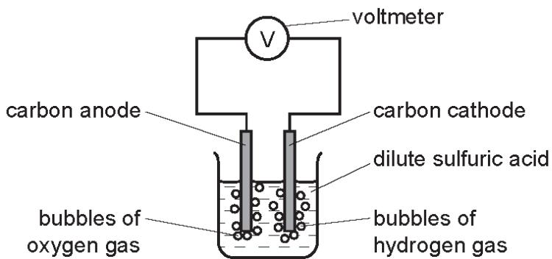
A reading on the voltmeter shows that electrical energy is being produced.
Suggest an explanation for how this energy is produced.

Explain why solid sodium chloride does not conduct electricity, whereas molten sodium chloride does conduct electricity.
..................................................................................................................................................................................................................................................................[3]
e.A concentrated aqueous solution of sodium chloride is electrolysed using carbon electrodes...................................................................................................................................................................................................................................................
f.Name the products formed at the electrodes. product at the positive electrode (anode) product at the negative electrode (cathode)
......................................................................................................................................................................................................................................................... [2]
ii.Write an ionic half- equation for the reaction occurring at the negative electrode.
..................................................................................................................................................................................................................................................................[1]
f. A dilute aqueous solution of sodium chloride is electrolysed using carbon electrodes. Name the main product formed at the positive electrode................................
g. Molten sodium chloride is electrolysed using carbon electrodes...............................
h. Name the product formed at the negative electrode.................................
ii.Write an ionic half- equation for the reaction occurring at the negative electrode.
.......................................................................................................................................
iii. Chlorine is produced at the positive electrode.
Give the test for chlorine.
test................................................................................................................................
result.............................................................................................................................
A student sets up the following electrolysis experiment.
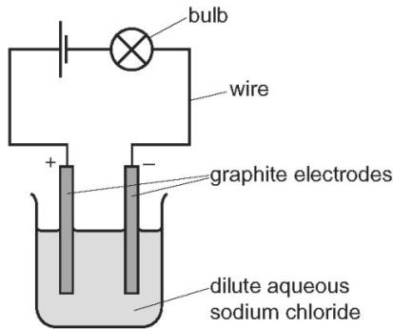
a.Define the term electrolysis.
..................................................................................................................................................................................................................................................................[2]
b.The student observes bubbles of colourless gas forming at each electrode.
c.Name the main gas produced at the positive electrode (anode).
..................................................................................................................................................................................................................................................................[1]
ii.Describe a test for the gas produced in (b)(i).
test..................................................................................................................................................................................................................................................................
result..................................................................................................................................................................................................................................................................[2]
iii.Write the ionic half- equation for the reaction taking place at the negative electrode (cathode).
..................................................................................................................................................................................................................................................................[2]
c.Charge is transferred during electrolysis.
Name the type of particle responsible for the transfer of charge in the wires, the electrolyte.
..................................................................................................................................................................................................................................................................[2]
d.The student replaces the dilute aqueous sodium chloride with concentrated aqueous sodium chloride.
Suggest two differences that the student observes.
1 ..................................................................................................................................................................................................................................................................
2 ..................................................................................................................................................................................................................................................................[2]
- (0620- W 2018- Paper 4 (Extended)/3- Q2) - ELECTRICITY AND CHEMICAL CHANGES
This question is about electrolysis.
a.i.What is meant by the term electrolysis?
...........................................................................................................................................................................................................................................................[2]
ii.Name the type of particle responsible for the conduction of electricity during electrolysis in: the metal wires, the electrolyte
...........................................................................................................................................................................................................................................................[2]
b.The table gives information about the products of the electrolysis of two electrolytes. Platinum electrodes are used in each case.
c.Give two reasons why platinum is suitable to use as an electrode.
1 ...........................................................................................................................................................................................................................................................
2....................................................................................................................................................................................................................................................... [2]
ii.Complete the table.
electrolyte | observation at the anode (+) | name of product at the anode (+) | observation at the cathode (-) | name of product at the cathode (-)
concentrated aqueous potassium chloride |  |  | bubbles of colourless gas
aqueous copper(II) sulfate | bubbles of colourless gas
[6]
Electrolysis of concentrated aqueous sodium chloride using inert electrodes forms chlorine, hydrogen and sodium hydroxide.
a.What is meant by the term electrolysis?
.............................................................................................................................................................................................................................................................
b.Name a substance that can be used as the inert electrodes.
.............................................................................................................................................................................................................................................................
c.Write an ionic half-equation for the formation of hydrogen during this electrolysis.
.............................................................................................................................................................................................................................................................
d.Give the formulae of the four ions present in concentrated aqueous sodium chloride.
.............................................................................................................................................................................................................................................................
e.Explain how sodium hydroxide is formed during this electrolysis.
.............................................................................................................................................................................................................................................................[2]

3.预测电解时的反应及其物质变化
1. The diagram shows that two gases are formed when concentrated hydrochloric acid is electrolysed using inert electrodes.
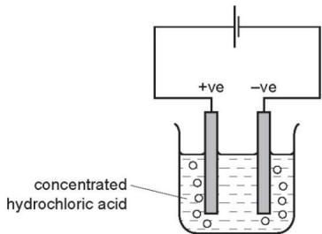
Which row correctly describes the colours of the gases at the electrodes? （ ）
 | anode (+ve) | cathode (-ve)
A | colourless | colourless
B | colourless | yellow-green
C | yellow-green | colourless
D | yellow-green | yellow-green

2. One molten compound and two aqueous solutions were electrolysed.
The table gives the compounds electrolysed and the electrodes used.
 | substance electrolysed | electrodes
1 | concentrated hydrochloric acid | carbon
2 | concentrated sodium chloride | platinum
3 | molten lead bromide | platinum
In which experiments is a gas evolved at the cathode? （ ）
A 1, 2 and 3 B 1 and 2 only C 1 only D 3 only

3. The diagram shows the electrolysis of concentrated aqueous sodium chloride.
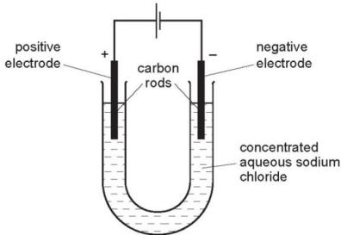
What is produced at each of the electrodes? （ ）
 | product at cathode | product at anode
A | hydrogen | chlorine
B | hydrogen | oxygen
C | sodium | chlorine
D | sodium | oxygen

4. In separate experiments, electricity was passed through concentrated aqueous sodium chloride and molten lead bromide.
What would happen in both experiments? （ ）
A A halogen would be formed at the anode.
B A metal would be formed at the cathode.
C Hydrogen would be formed at the anode.
D Hydrogen would be formed at the cathode.

5. The diagram shows an electrolysis circuit.
At which electrode is hydrogen formed?
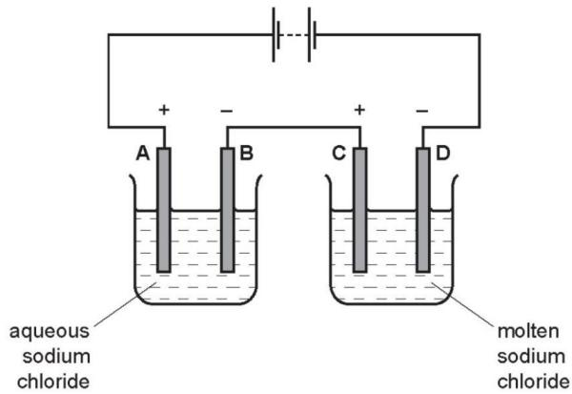
Concentrated aqueous sodium chloride, concentrated hydrochloric acid and molten lead bromide were separately electrolysed in experiments 1, 2 and 3.
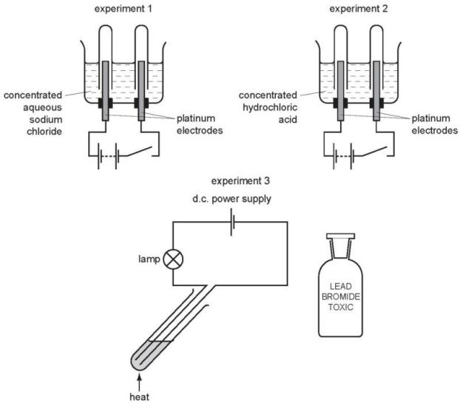
Which statement about the electrode products is correct? （ ）
A Gases were given off at the anode in experiments 2 and 3 only.
B Gases were given off at the cathode in experiments 1 and 2 only.
C Metals were formed at the anode in experiments 1 and 3 only.
D Metals were formed at the cathode in experiments 1 and 3 only.
6. - (0620- W 2013- Paper 1 (Core)/3- Q10) - ELECTRICITY AND CHEMICAL CHANGES
Two electrolysis experiments were carried out as shown in the diagram below.
The graphite electrodes are labelled 1- 4.
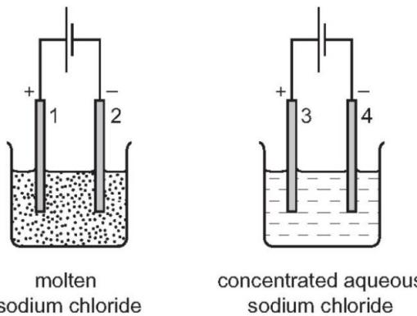
Which row describes the products at the electrodes in these experiments? （ ）
 | electrode 1 | electrode 2 | electrode 3 | electrode 4
A | chlorine | hydrogen | chlorine | hydrogen
B | chlorine | sodium | chlorine | hydrogen
C | chlorine | sodium | hydrogen | chlorine
D | sodium | chlorine | sodium | chlorine
7. What will be produced at the anode and at the cathode, if molten potassium chloride is electrolysed? （ ）
 | anode (+) | cathode (-)
A | chlorine | hydrogen
B | chlorine | potassium
C | hydrogen | chlorine
D | potassium | chlorine

8 . Which reactions could take place at the anode during electrolysis? （ ）
$$\begin{aligned}&1 4{OH}^{−}(aq)→2H_{2}O(l)+O_{2}(g)+4e^{−} \\ &2{Cl}^{−}(aq)→{Cl}_{2}(g)+2e^{−} \\ &3 {Cu}^{2+}(aq)+2e^{−}→Cu(s) \\ &4 2H^{+}(aq)+2e^{−}→H_{2}(g)\end{aligned}$$
A 1 and 2 B 1 and 4 C 2 and 4 D 3 and 4

9. The diagram shows the electrolysis of molten zinc chloride, $ZnCl_{2}$ .
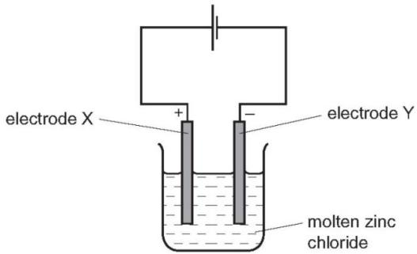
Which statement is correct? （ ）
A Oxidation occurs at electrode X and the equation is: $2Cl^{−}→Cl_{2}+2e^{−}$
B Oxidation occurs at electrode Y and the equation is: $Zn^{2+}+2e^{−}→Zn$
C Reduction occurs at electrode X and the equation is: $Zn^{2+}+2e^{−}→Zn$
D Reduction occurs at electrode Y and the equation is: $2Cl^{−}→Cl_{2}+2e^{−}$

10. Aqueous copper(II) sulfate is electrolysed using carbon electrodes.
What is the product at each electrode? （ ）
 | product at the positive electrode | product at the negative electrode
A | copper | oxygen
B | hydrogen | oxygen
C | oxygen | copper
D | oxygen | hydrogen

11. Which statement about the electrolysis of copper(II) sulfate solution using carbon electrodes is correct? （ ）
A. A colourless gas is produced at the anode.
B. A colourless gas is produced at the cathode.
C. The colour of the electrolyte remains the same.
D. The mass of both electrodes remains constant.

12. Which products are formed at the anode and cathode when electricity is passed through molten lead(II) bromide? （ ）
 | anode (+) | cathode (-)
A | bromide ions | lead ions
B | bromine molecules | lead atoms
C | lead atoms | bromine molecules
D | lead ions | bromide ions

13. An aqueous solution of copper(II) sulfate was electrolysed using copper electrodes.
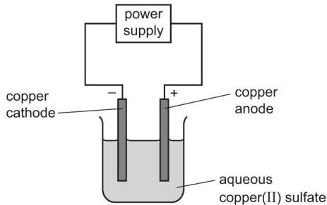
Which equation for the reaction at the anode is correct? （ ）
A $Cu→{Cu}^{2+}+2e^{−}$
B $Cu+2e^{−}→Cu^{2+}$
C ${Cu}^{2+}→Cu+2e^{−}$
D ${Cu}^{2+}+2e^{−}→Cu$

14. Which rows correctly show cathode and anode products from the electrolysis of the named electrolyte? （ ）
 | electrolyte | cathode product | anode product
1 | copper(II) sulfate solution using copper electrodes | copper | oxygen
2 | molten lead(II) bromide | lead | bromine
3 | dilute sodium bromide solution | hydrogen | oxygen
4 | copper(II) sulfate solution using carbon electrodes | hydrogen | oxygen
A 1 and 2 only B 1 and 4 only C 2 and 3 only D 3 and 4 only

15. Electrolytes can be broken down by electrolysis.
Which rows are correct for each electrolyte? （ ）
 | electrolyte | reaction at cathode | product at anode
1 | dilute aqueous sodium chloride | 2H⁺ + 2e−→ H₂ | oxygen
2 | concentrated hydrochloric acid | 2H⁺ + 2e−→ H₂ | chlorine
3 | molten aluminium oxide | 2O²⁻→ O₂+ 4e⁻ | aluminium
4 | concentrated aqueous sodium bromide | Na⁺ + e−→ Na | bromine
A 1 and 2 B 1 and 4 C 2 and 3 D 3 and 4

16. Electrolysis is carried out on dilute aqueous potassium bromide.
Which products are formed at the anode and the cathode? （ ）
 | anode | cathode
A | bromine | hydrogen
B | bromine | potassium
C | hydrogen | bromine
D | hydrogen | potassium
17. Chemical reactions are always accompanied by an energy change.
a.Aluminium is extracted by the electrolysis of a molten mixture which contains aluminium oxide, $Al_{2}O_{3}$ . This decomposes to form aluminium at the negative electrode and oxygen at the positive electrode.
b.Write an ionic equation for the reaction at the negative electrode.
......................................................................................................................................................................................................................................................... [2]
ii.Complete the ionic equation for the reaction at the positive electrode.
$${20}^{2−}→……+……$$
iii.Is the reaction exothermic or endothermic? Explain your answer.
b.The cell shown below can be used to determine the order of reactivity of metals.
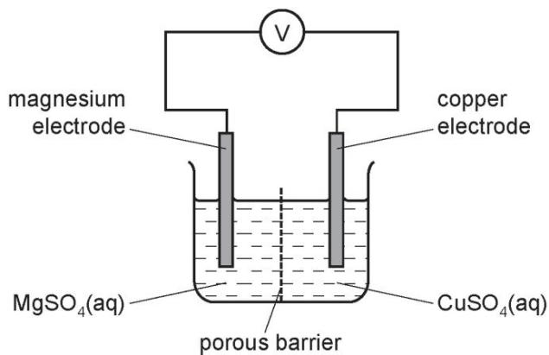
i.Is the reaction in the cell exothermic or endothermic? Explain your answer.
ii.Explain why the mass of the magnesium electrode decreases and the mass of the copper electrode increases.
..........................................................................................................................................................................................................................................................................[2]
iii.How could you use this cell to determine which is the more reactive metal, magnesium or manganese?
...........................................................................................................................................................................................................................................................................[2]
c.The combustion of propane, $C_{3}H_{8}$ , is exothermic.
Give an equation for the complete combustion of propane.
...........................................................................................................................................................................................................................................................................[2]

18. Solutions of ionic compounds can be broken down by electrolysis.
a.Concentrated aqueous copper(II) chloride was electrolysed using the apparatus shown.
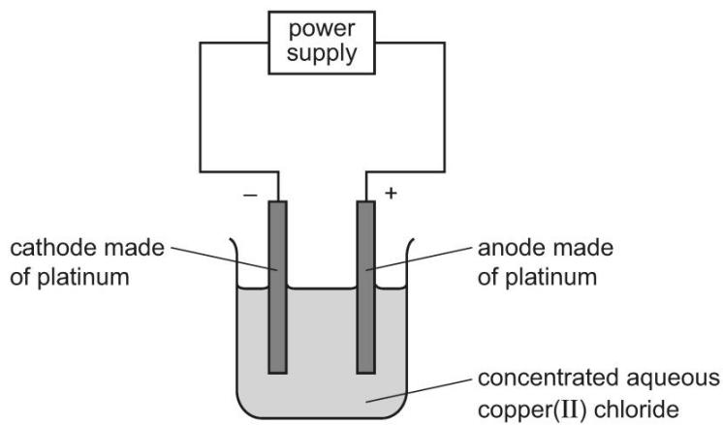
The ionic half- equations for the reactions at the electrodes are shown.
negative electrode: ${Cu}^{2+}(aq)+2e^{−}→Cu(s)$ positive electrode: $2{Cl}^{−}(aq)→{Cl}_{2}(g)+2e^{−}$
i.Platinum is a solid which is a good conductor of electricity. State one other property of platinum which makes it suitable for use as electrodes.
.............................................................................................................................................................................................................................................................[1]
ii.State what would be seen at the positive electrode during this electrolysis.
............................................................................................................................................................................................................................................................. [1]
iii.State and explain what would happen to the mass of the negative electrode during this electrolysis.
............................................................................................................................................................................................................................................................. [2]
iv.The concentrated aqueous copper(II) chloride electrolyte is green.
Suggest what would happen to the colour of the electrolyte during this electrolysis. Explain your answer.

v.Identify the species that is oxidised during this electrolysis. Explain your answer.
species that is oxidised..........................
explanation
b.Metal objects can be electroplated with silver.
c.Describe how a metal spoon can be electroplated with silver. Include:
what to use as the positive electrode and as the negative electrode what to use as the electrolyte an ionic half- equation to show the formation of silver.
You may include a diagram in your answer.
ionic half- equation
.............................................................................................................................................................................................................................................................
ii.Give one reason why metal spoons are electroplated with silver.
[1]
a.Displacement reactions occur between metals and metal ions.
Displacement reactions can be used to determine the order of reactivity of metals such as lead (Pb), nickel (Ni), and silver (Ag).
The ionic equation for a displacement reaction is shown.
$$Ni(s)+Pb^{2+}(aq)→Pb(s)+Ni^{2+}(aq)$$
The ionic half- equations for this reaction are shown.
$$Ni(s)→Ni^{2+}(aq)+2e^{−}$$
$$Pb^{2+}(aq)+2e^{−}→Pb(s)$$
The ionic half- equations show that electrons are donated by nickel atoms and accepted by lead ions.
i.Identify the reducing agent in the displacement reaction. Give a reason for your answer. reducing agent. reason.
.............................................................................................................................................................................................................................................................[2]
ii.What is the general term given to the type of reaction in which electrons are transferred from one species to another?
.............................................................................................................................................................................................................................................................[1]
b.The ionic equation for another displacement reaction is shown.
$$Pb(s)+2Ag^{+}(aq)→2Ag(s)+Pb^{2+}(aq)$$
Write the two ionic half- equations for this reaction.
1 .............................................................................................................................................................................................................................................................
2 .............................................................................................................................................................................................................................................................[2]
c.Use the information ind.and e.to put the three metals lead, nickel and silver in order of reactivity.
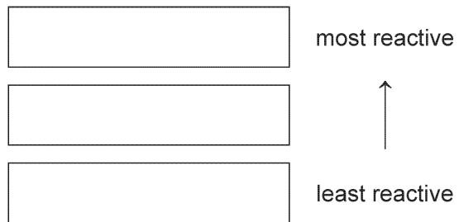
d.Nickel is a transition element. Nickel is stronger than sodium.
Describe two other differences in the physical properties of nickel and sodium.
1 .............................................................................................................................................................................................................................................................
2 .............................................................................................................................................................................................................................................................[2]
e.Predict one difference in the appearance of aqueous solutions of nickel compounds compared to aqueous solutions of sodium compounds.
.............................................................................................................................................................................................................................................................[1]
f.Copper is refined (purified) by electrolysis. Nickel can be refined using a similar method.
g.The diagram shows the refining of nickel by electrolysis.
Complete the labels in the boxes.
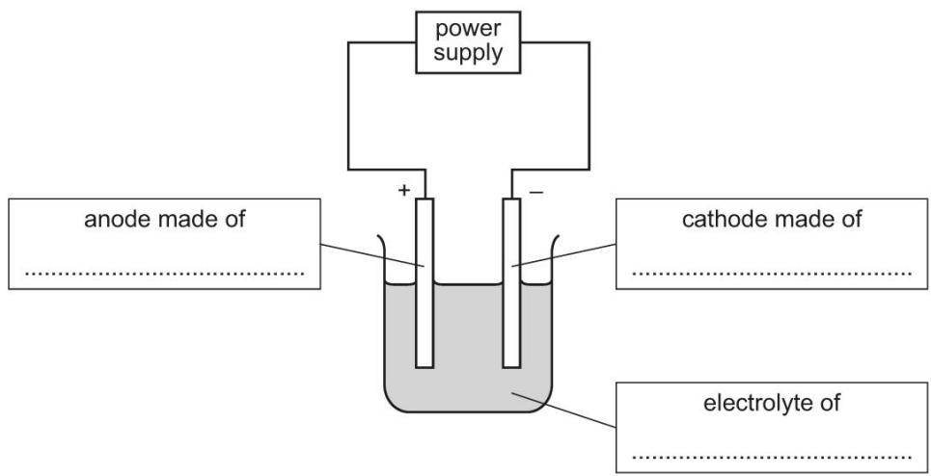
ii.Indicate, by writing N on the diagram, where nickel is produced.
.............................................................................................................................................................................................................................................................[3]

Which products are formed at the electrodes when a concentrated solution of sodium chloride is electrolysed?
 | cathode (-) | anode (+)
A | hydrogen | chlorine
B | hydrogen | oxygen
C | sodium | chlorine
D | sodium | oxygen

4 根据产物判断电极
1. In the electrolysis shown, chlorine is produced at W and sodium at X.
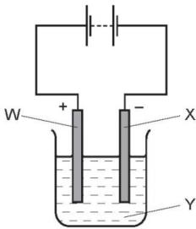
Which labels are correct?（ ）
 | W | X | Y
A | anode | cathode | NaCl (l)
B | anode | cathode | NaCl (aq)
C | cathode | anode | NaCl (l)
D | cathode | anode | NaCl (aq)

2. The diagram shows the electrolysis of concentrated hydrochloric acid and concentrated aqueous sodium chloride using carbon electrodes.
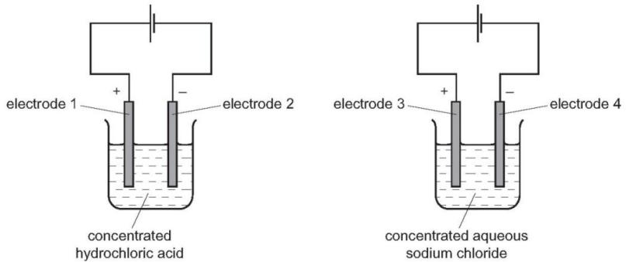
At which electrode(s) is hydrogen produced? （ ）
A electrode 1 only
B electrodes 1 and 3
C electrode 2 only
D electrodes 2 and 4

3. Which row describes the electrolysis of molten potassium bromide?（ ）
 | product at anode | product at cathode
A | bromine | hydrogen
B | bromine | potassium
C | hydrogen | bromine
D | potassium | bromine

4. Aluminium is extracted from bauxite by electrolysis.
Which row shows the anode material and the anode reaction?（ ）
 | anode material | anode reaction
A | carbon | Al³⁺ + 3e−→ Al
B | carbon | 2O2−→ O₂ + 4e−
C | steel | Al³⁺ + 3e⁻→ Al
D | steel | 2O²⁻→ O₂ + 4e−

5. The diagram shows the electrolysis of an aqueous solution of X using inert electrodes.
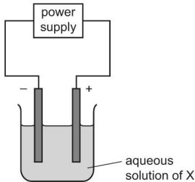
Hydrogen is produced at the cathode and chlorine is produced at the anode.
What is X?（ ）
A concentrated copper(II) chloride solution
B concentrated hydrochloric acid
C dilute hydrochloric acid
D dilute sodium chloride solution

6. Copper and hydrogen can each be formed by electrolysis. At which electrodes are these elements formed? （ ）
 | copper | hydrogen
A | anode | anode
B | anode | cathode
C | cathode | anode
D | cathode | cathode

7. Iron and steel rust when exposed to water and oxygen. Rust is hydrated iron(III) oxide.
a. The following cell can be used to investigate rusting.
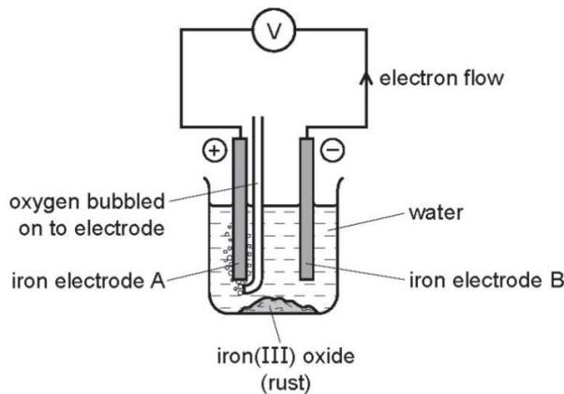
i.What is a cell?
....................................................................................................................................................................................................................................................................... [3]
ii.Which electrode will be oxidised and become smaller? Explain your choice.
.....................................................................................................................................................................................................................................................................
iii.What measurements would you need make to find the rate of rusting of the electrode you have chosen in (ii)?

iv.Suggest an explanation why the addition of salt to the water increases the rate of rusting..............................................................................................................................................................................................................................................................[1]
Lithium bromide is an ionic compound. It can be electrolysed when it is molten or in aqueous solution. It cannot be electrolysed as a solid.
a.Solid lithium bromide is a poor conductor of electricity. The ions cannot move to the electrodes, they are held in an ionic lattice by strong forces.
b.Describe the motion of the ions in the solid state.
...........................................................................................................................................................................................................................................................................[1]
ii.Define the term ionic bonding.
....................................................................................................................................................................................................................................................................[2]
iii.What is meant by the term ionic lattice?
.....................................................................................................................................................................................................................................................................[2]
b.The diagram shows the electrolysis of molten lithium bromide.
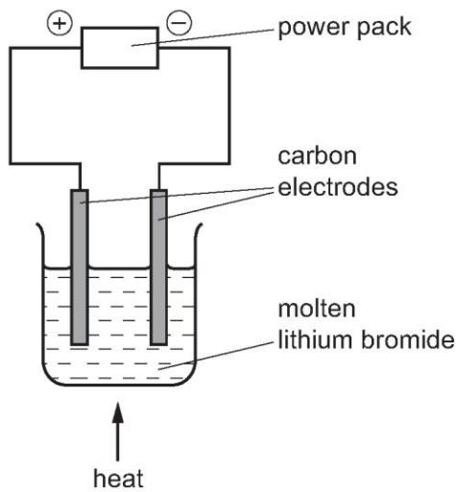
i.Mark on the diagram the direction of the electron flow. [1]
ii.Write an ionic equation for the reaction at the negative electrode (cathode).
...................................................................................................................................................................................................................................................................[1]
(iii) Write an ionic equation for the reaction at the positive electrode (anode).
....................................................................................................................................................................................................................................................................[2]
iii.Which ion is oxidised? Explain your answer.
...........................................................................................................................................................................................................................................................................[2]
c.When aqueous lithium bromide is electrolysed, a colourless gas is formed at the negative electrode and the solution becomes alkaline.
Explain these observations and include an equation in your explanation.
...........................................................................................................................................................................................................................................................................[3]

5.根据不同种类的电极判断产物
1. What are the electrode products when molten silver iodide is electrolysed between inert electrodes?（ ）
 | cathode | anode
A | hydrogen | iodine
B | iodine | silver
C | silver | iodine
D | silver | oxygen

2. What are the ionic half- equations for the electrode reactions during the electrolysis of concentrated aqueous sodium chloride?（ ）
 | anode | cathode
A | Cl₂+ 2e⁻→ 2Cl⁻ | H₂→ 2H⁺ + 2e−
B | 2Cl⁻→ Cl₂+ 2e− | 2H⁺ + 2e−→ H₂
C | H2→ 2H⁺ + 2e− | Cl₂+ 2e−→ 2Cl−
D | 2H⁺ + 2e−→ H2 | 2Cl−→ Cl₂ + 2e−

3. Electrolysis of copper(II) sulfate can be done using either carbon electrodes or copper electrodes.
Which statement describes what happens at the positive electrode?（ ）
A Copper is deposited if the electrode is made from carbon.
B Copper is deposited if the electrode is made from copper.
C Oxygen gas is produced if the electrode is made from carbon.
D Oxygen gas is produced if the electrode is made from copper.

4. Concentrated aqueous copper(II) chloride is electrolysed using copper electrodes as shown.
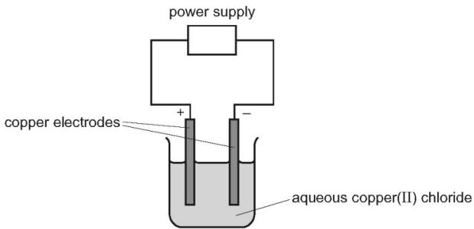
What happens to the mass of each electrode during this process?（ ）
 | positive electrode | negative electrode
A | decreases | decreases
B | decreases | increases
C | increases | decreases
D | increases | increases

5. The diagram shows a method used to copper- plate a pan
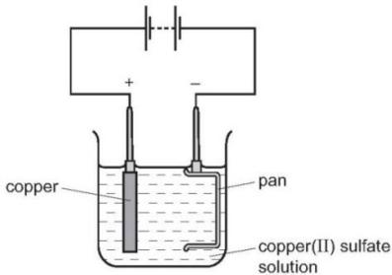
Which equation represents the reaction at the cathode?（ ）
A $Cu^{2+}+2e^{−}→Cu$
B $2H^{+}+2e^{−}→H_{2}$
C $40H^{−}→O_{2}+2H_{2}O+4e^{−}$
D ${20}^{2−}→O_{2}+4e^{−}$

6.电镀的原理和装置的作用
1. The diagram shows an unsuccessful experiment to nickel plate a pan.
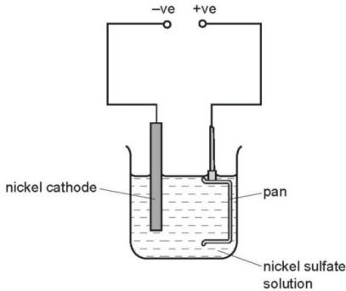
Which change is necessary to plate the pan with nickel? （ ）
A Add more nickel sulfate to the solution.
B Heat the solution to ${100}^{∘}C$
C Increase the current in the circuit.
D Make the pan the negative electrode.

2. The diagram shows a failed attempt to copper- plate a pan.
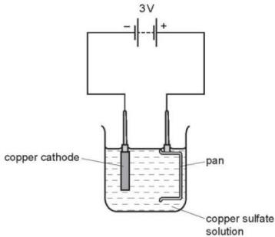
Which action will plate the pan with copper? （ ）
A cooling the copper sulfate solution in an ice bath
B heating the copper sulfate solution to boiling point
C increasing the voltage from 3V to 6V
D making the pan the cathode and the copper the anode

7.电镀时的各个部分的物质的选取
1. Winston Churchill, a British Prime Minister, had his false teeth electroplated with gold.
The teeth were coated with a thin layer of carbon and were then placed in the apparatus shown.
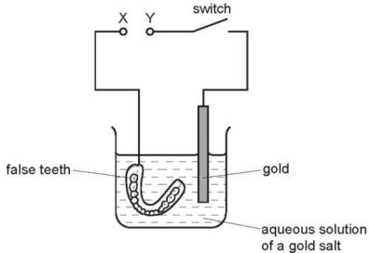
Which row is correct?
 | terminal X is | the carbon powder could be
A | negative | diamond
B | negative | graphite
C | positive | diamond
D | positive | graphite

2. Which apparatus could be used to electroplate an iron nail with copper?（ ）
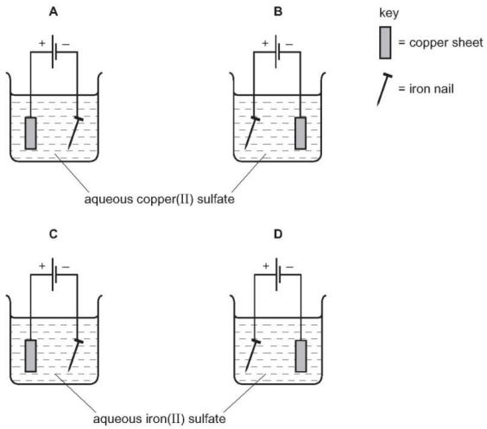
3. The diagram shows an electrolysis experiment using metals X and Y as electrodes.
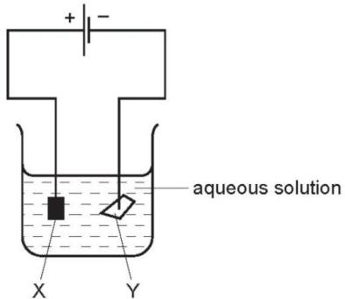
One of the metals becomes coated with copper.
Which metal becomes coated and which aqueous solution is used? （ ）
 | metal | aqueous solution
A | X | CrCl₃
B | X | CuCl₂
C | Y | CrCl₃
D | Y | CuCl₂

4.Which metal could not be used for electroplating by using an aqueous solution? （ ）
A chromium B copper C silver D sodium

5. The diagram shows the electroplating of a steel object.
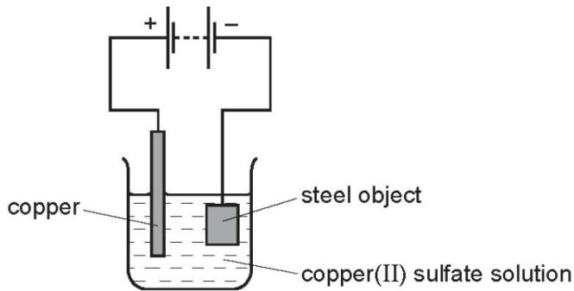
A student made the following statements.
1 The object turns a reddish- brown colour.
2 The copper sulfate solution changes to a paler blue colour.
3 The copper electrode becomes smaller.
Which statements are correct? （ ）
A 1, 2 and 3 B 1 and 2 only C 1 and 3 only D 2 and 3 only

6. An object is electroplated with silver using an aqueous silver salt as the electrolyte.
Which set of conditions is used?（ ）
 | the object to be electroplated is the | the other electrode is made from
A | anode | carbon
B | anode | silver
C | cathode | carbon
D | cathode | silver

7. Electroplating steel objects with silver involves a three- step process.
step 1 A coating of copper is applied to the object.
step 2 A coating of nickel is applied to the object.
step 3 The coating of silver is applied to the object.
a.A diagram of the apparatus used for step 1 is shown.
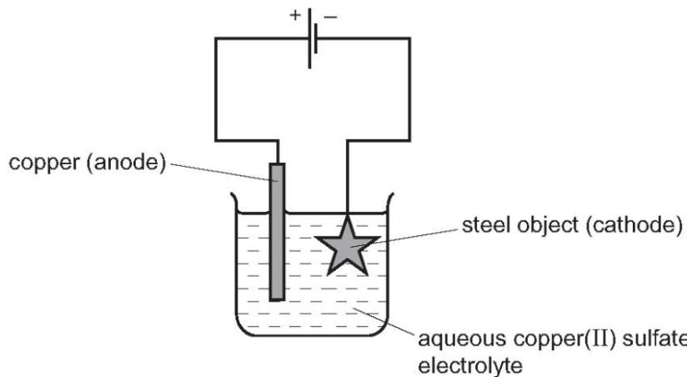
i.The chemical process taking place on the surface of the object is
$${Cu}^{2+}(aq)+2e^{−}→Cu(s)$$
Explain whether this process is oxidation or reduction.
..........................................................................................................................................................................................................................................................................[1]
ii.Explain why the concentration of copper ions in the electrolyte remains constant throughout step 1.

b.Give two changes which would be needed in order to coat nickel onto the object in step 2.

c.Copper, nickel and silver are transition elements. Typical physical properties of transition elements are a high density and a high melting point.
Give three different properties of transition metals which are not typical of other metals.


8.铝的制取时的电解原理
1. Aluminium metal is extracted from aluminium oxide by electrolysis.
Which ionic half-equation describes a reaction that occurs at the named electrode? （ ）
 | ionic half-equation | electrode
A | 2O²⁻→ O₂+ 2e⁻ | anode
B | Al³⁺→ 3e⁻→ Al | anode
C | 2O²⁻→ O₂+ 4e⁻ | cathode
D | Al³⁺→ 3e⁻→ Al | cathode

2. Aluminium is extracted by electrolysis as shown.
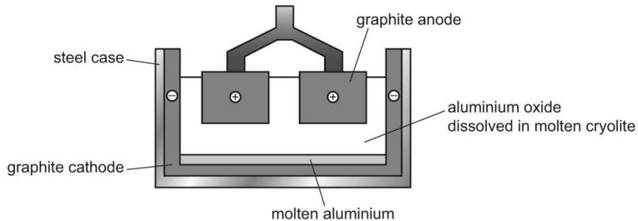
Which row shows the ionic half- equations at the cathode and the anode?（ ）
 | cathode | anode
A | Al³⁺→ Al + 3e⁻ | 2O²⁻→ O₂+ 4e⁻
B | Al³⁺→ Al + 3e- | 2O²⁻+ 4e-→ O₂
C | Al³⁺ + 3e-→ Al | 2O2⁻→ O₂+ 4e-
D | Al³⁺ + 3e-→ Al | 2O²⁻+ 4e-→ O₂
3. Two of the main uses of zinc are for galvanising and for making alloys.
One of the main ores of zinc is zinc blende, ZnS. There are two stages in the extraction of zinc from this ore.
a.Stage 1 Zinc oxide is made from zinc blende.
Describe how this is done and write a word equation for the reaction.

b.Stage 2 Zinc oxide is reduced to zinc.
Write a word equation for the reduction of zinc oxide by coke.
...........................................................................................................................................................................................................................................................................[1]
c.The zinc produced by this process is impure. It can be purified by electrolysis using a method which is similar to the purification of copper. Under the conditions used in the process, zinc is the product at the negative electrode (cathode).
Complete the following description of this purification.
The electrolyte is aqueous. ...............................................................[1]
The negative electrode (cathode) is made of ..........................................[1]
The positive electrode (anode) is impure zinc.
The equation for the reaction at the cathode is ..........................................[1]
The equation for the reaction at the anode is ..........................................[1]
Explain why the concentration of the electrolyte does not change.
..........................................................................................................................................................................................................................................................................[2]
d.Brass is an alloy which contains zinc.
e.Name the other metal in brass.
.........................................................................................................................................................................................................................................................................[1]
ii.Suggest two reasons why an alloy such as brass is preferred to either of its constituent metals.
.........................................................................................................................................................................................................................................................................[2]
e.In an experiment to investigate the rate of rusting of steel, three pieces of steel were used. One piece of steel was completely coated with copper, one piece completely coated with zinc and the third piece was left uncoated. All three pieces were left exposed to the atmosphere.
f.Explain why the uncoated piece started to rust.
...........................................................................................................................................................................................................................................................................[1]
ii.The coating on both of the other two pieces was scratched, exposing the steel.
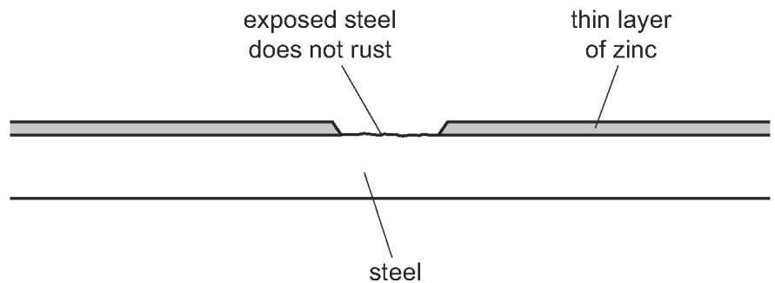
The piece of steel coated with zinc still did not rust but the copper- coated piece of steel rusted very rapidly.
Explain these observations in terms of the formation of ions and the transfer of electrons.


9.氢燃料电池的原理
1. Which statement about the hydrogen fuel cell is not correct?（ ）
A Chemical energy is converted into electrical energy.
B Hydrogen is oxidised.
C The reaction that takes place is endothermic.
D Water is the only product.

2. Fuel cells are used as energy sources in cars.
Which row gives a fuel used in a fuel cell and the products formed?（ ）
 | fuel in a fuel cell | products formed
A | hydrogen | carbon dioxide and water
B | hydrogen | water only
C | petrol | carbon dioxide and water
D | petrol | water only

3. Which statement about a fuel cell in a car is correct?（ ）
A The fuel cell produces heat, which powers the car.
B The fuel cell is supplied with hydrogen directly from the air.
C The only emission from a fuel cell is nitrogen gas, which is non- polluting.
D The fuel cell produces electricity, which powers an electric motor.

4. Which statements about hydrogen fuel cells are correct?（ ）
1 Water is formed as the only waste product.
2 Both water and carbon dioxide are formed as waste products.
3 The overall reaction is $2H_{2}+O_{2}→2H_{2}O$
4 The overall reaction is endothermic.
A 1 and 3 B 1 and 4 C 2 and 3 D 2 and 4

5. Hydrogen can be manufactured from methane by steam reforming.
$${CH}_{4}(g)+H_{2}O(g)⇌CO(g)+3H_{2}(g)$$
The reaction is carried out using a nickel catalyst at temperatures between ${700}^{∘}C$ and ${1100}^{∘}C$ and using a pressure of one atmosphere.
The forward reaction is endothermic.
a.What is meant by the term catalyst?
...............................................................................................................................
................................................................................................................................
b.Suggest two reasons why a temperature lower than ${700}^{∘}C$ is not used.
..................................................................................................................................
..................................................................................................................................
c.Suggest one advantage of using a pressure greater than one atmosphere.
...........................................................................................................................................................................................................................................................................[1]
d.Suggest one disadvantage of using a pressure greater than one atmosphere.
..........................................................................................................................................................................................................................................................................
e.Hydrogen can also be manufactured by electrolysis. The electrolyte is concentrated aqueous sodium chloride. The electrodes are inert.
6. The products of electrolysis are hydrogen, chlorine and sodium hydroxide.
i.Define the term electrolysis.
...................................................................................................................................................................................................................................................................[2]
ii.Name a substance that can be used as the inert electrodes. [1]
..................................................................................................................................................................................................................................................................
iii.Write an ionic half- equation for the reaction in which hydrogen is produced.
..................................................................................................................................................................................................................................................................[1]
iv.Where is hydrogen produced in the electrolytic cell?
..................................................................................................................................................................................................................................................................[1]

7. Hydrogen and oxygen react together in a hydrogen fuel cell. A hydrogen fuel cell is shown in the diagram.
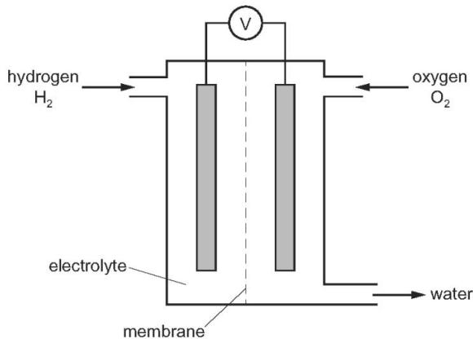
a.Name the process by which oxygen is obtained from air.
b.i.In a hydrogen fuel cell, the hydrogen molecules are converted into hydrogen ions, $H^{+}$ , according to the ionic half-equation shown.
$$H_{2}→2H^{+}+2e^{−}$$
What type of reaction does this ionic half- equation represent?
ii.What type of substance reacts by donating hydrogen ions, $H^{+}$ ?.....................
iii.Write a chemical equation for the overall reaction that occurs in a hydrogen fuel cell............................................................................................
iv.Hydrogen fuel cells are being developed as alternatives to petrol engines in cars.
v.Give one advantage of hydrogen fuel cells compared to petrol engines.
.................................................................................................................................................................................................................................................................
vi.Give one disadvantage of hydrogen fuel cells compared to petrol engines.
...............................................................................................................................................................................................................................................................
e.Some fuel cells use ethanol, $C_{2}H_{5}OH$ , instead of hydrogen. Carbon dioxide and water are products of the reaction in an ethanol fuel cell.
f.Write a chemical equation for the overall reaction occurring in an ethanol fuel cell.
...............................................................................................................................................................................................................................................................
ii.State an environmental problem caused by the release of carbon dioxide into the atmosphere.
...............................................................................................................................................................................................................................................................
f.Name the process occurring when electrical energy is used to break down an ionic compound..................................................................................................................................................................................................................................................

